
Conference Room Reservation Form
Event Information All Fields must be complete
Date of Event(일자) |  |  | June 25, 2026 |  | Event Time
Number of Attendees |  |  | 80 |  | Start Time: 5pm |  | End Time: 10pm
Event/Meeting Name(제목) |  |  | AI Nexus’s 1st Chapter: The Silicon Stethoscope - Bridging Korea's Medical Reality and Silicon Valley's AI Vision in Healthcare's Trillion Dollar Transformation
Purpose of Event/Meeting  Visitors Name |  |  | Silicon Valley AI Nexus (AI Nexus) monthly forum on healthcare AI, featuring two keynote talks and a panel discussion. Speakers: Dr. Jong Hyeok Kim, MD, PhD (Asan Medical Center, Seoul) and Dr. Sunghee Yun (Co-Founder & CTO, Erudio Bio). Dinner reception sponsored by KIC Silicon Valley. Approximately 80 attendees including AI professionals, physicians, healthcare practitioners, investors, and academic researchers.
Applicant Information
Name of Company/Organization |  |  |  | Erudio Bio, Inc.
Event Coordinator |  |  | Sunghee Yun |  |  | Request Date | June 11, 2026
Email |  |  | sunghee.yun@gmail.com |  |  | Phone No. | 408-549-4077
Conference Room Information
Select Conference Room(s)/회의실 선택 |  |  |  |  |  |  | Equipment Needs  기타 기자재 신청
Name | Capacity | Equipped |  |  |  |  | ☒Projector  ☒Audio
☐Idaho | 10 | TV, Table(1), Chair(10)
☐Washington | 10 | TV, Table(1), Chair(10)
☐Oregon | 15 | Projector, Table(1), Chair(15)
☐California | 20-50 | Projector, Podium(1), Mic(2),  Table(12), Chair(40)
☒Alaska | 50-120 | Projector, Podium(1), Mic(2),  Table(30), Chair(100)
Comments or Special Notes

Cancellation Policy
KOTRA requires 72 hours notice prior to a reservation for cancellation without penalty. If a reservation is canceled with less than three business day notice the organizer is responsible for the cost of the room rental associated with their reservation.
General Rules
Persons attending a meeting must restrict their activities to the meeting room and the restrooms on the floor on which the meeting room is located. Under no circumstances entering the area of business offices is permitted
All meetings must end on time and the room must be vacated in a timely manner
Closing the door when meeting is in progress as noise and/or conversations could be interruptive to nearby offices.
Conference rooms must be left in a clean and orderly condition.
Charges may apply for damages and/or if extra clean-up is required.
Nothing is to be attached to the ceiling or fixtures. Use of nails, screws or staples on walls is prohibited.
All equipment and furniture must not be removed from this property. Charges apply for replacement.
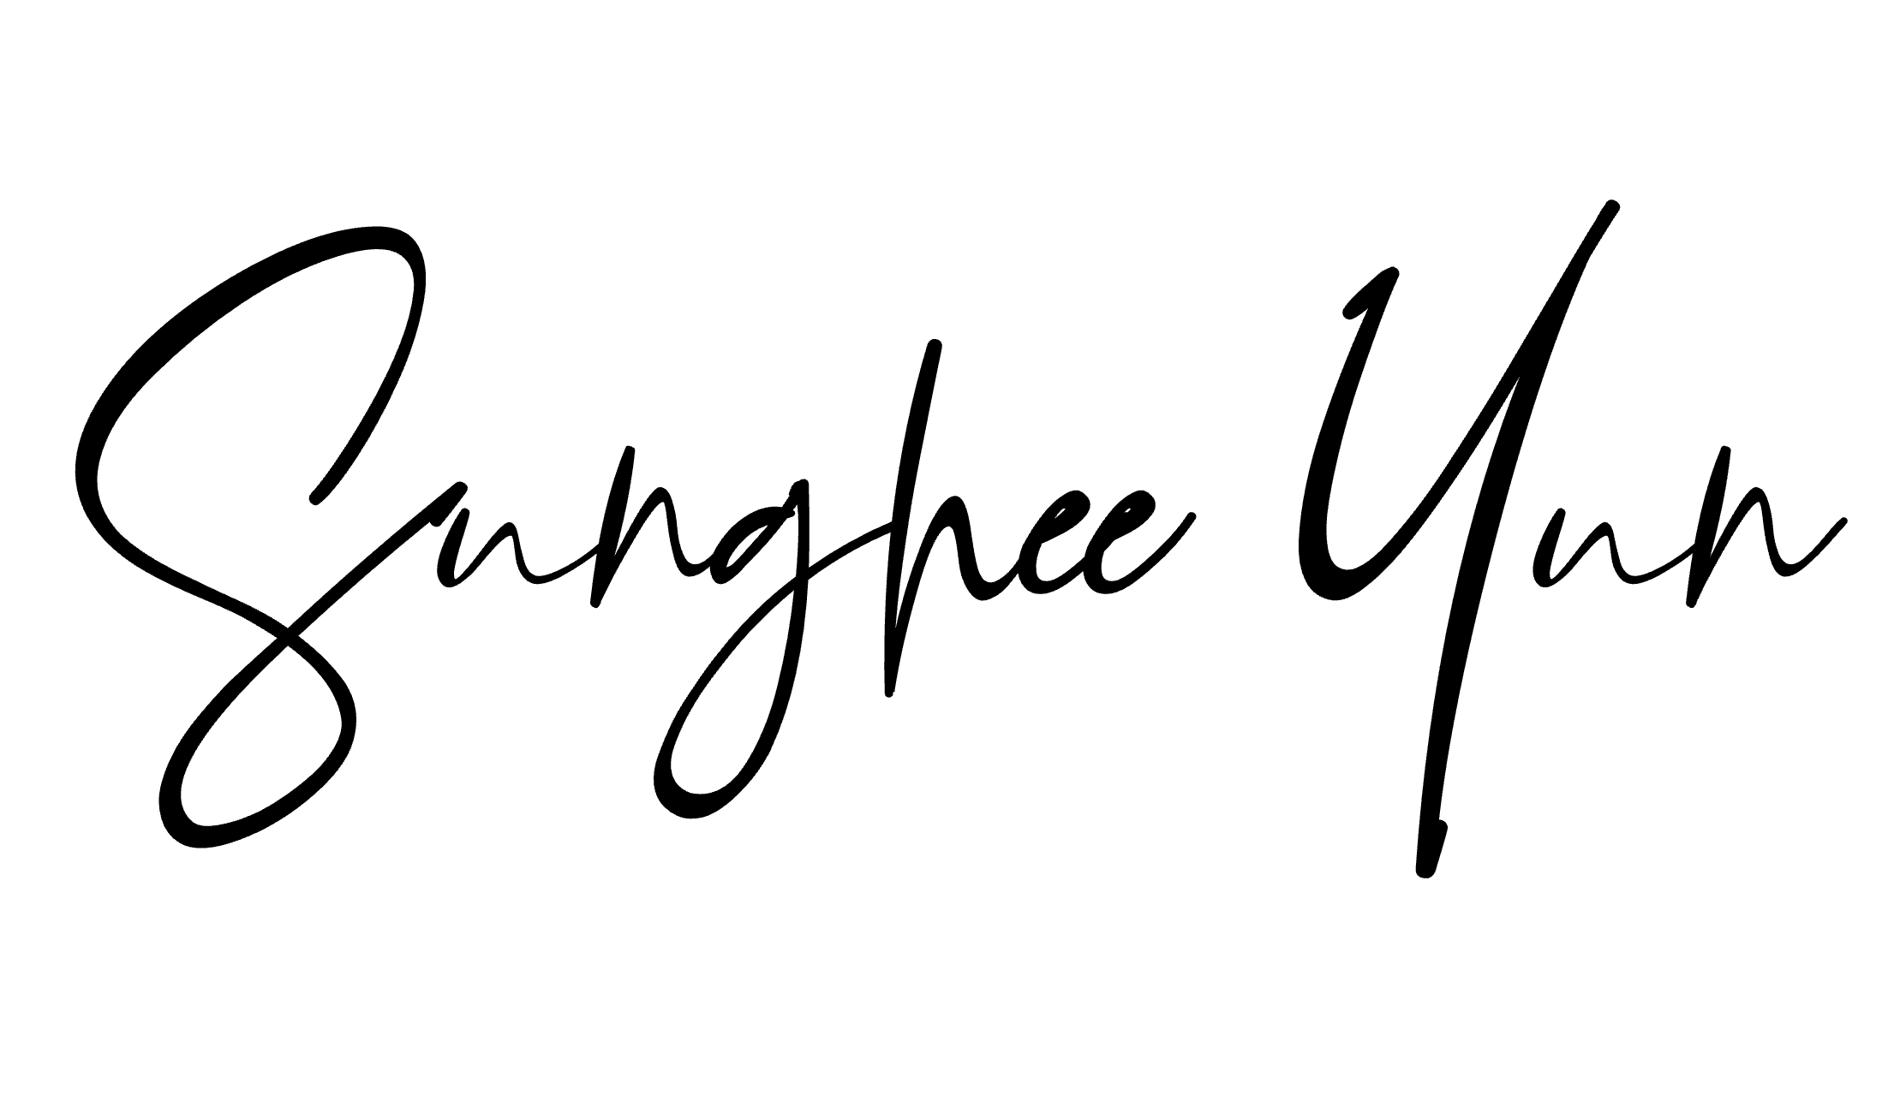
Organizer is responsible for all arrangements and associated clean-up related to food and beverage service.
Food and beverage(water) service is not provided
Applicant’s Signature: Date: June 11, 2026
Please submit a completed form to IT center

